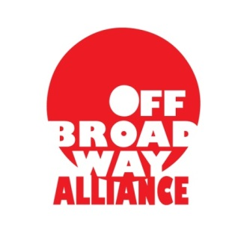
Mentorship Application Form

Name:_______________________________________________________________________________

Address:_____________________________________________________________________________

Phone:__________________________________ Email:____________________@________________

Website:_____________________________________________________________________________

Type of OBA Membership (membership is required): FULL ASSOCIATE

Essay 1:
Describe your artistic/theatrical project. Please include specific details on how the project begin, how the project is currently coming along, the overall goal for the finished project, etc.
(500 word max)

Essay 2:
What have your biggest struggles been with your artistic/theatrical project?
(250 word max)

Essay 3:
How would the OBA Mentorship Program enhance your artistic/theatrical project?
(250 word max)

Essay 4:
What is the origin of your interest in working in theatre?
(250 word max)

